**Laboratory Assignment 5**

**On**

**Design Principles of Operating System**

**(CSE 3249)**

**Submitted by**

**Name : Dinanath Dash**

**Reg. No. : 2241004161**

**Semester : 5th**

**Branch : CSE**

**Section : 2241026**

**Session : 2024-2025**

**Admission Batch : 2022**



**DEPARTMENT OF COMPUTER SCIENCE & ENGINEERING**

**FACULTY OF ENGINEERING & TECHNOLOGY (ITER)**

**SIKSHA ‘O’ ANUSANDHAN DEEMED TO BE UNIVERSITY**

**BHUBANESWAR, ODISHA – 751030**

**Assignment 5: Implementation of synchronization using semaphore:**

**Objective of this Assignment:**

* To implement the concept of multi-threading in a process.
* To learn the use of semaphore i.e., to control access to shared resources.

1. Producer-Consumer problem Problem:

Write a C program to implement the producer-consumer program where:

* Producer generates integers from 1 to 100.
* Consumer processes the numbers.

Requirements:

* Use a shared buffer with a maximum size of 10.
* Use semaphores and mutex to ensure thread-safe access to the buffer.
* Print the number that producer is producing and consumer is consuming.
* Both producer and consumer will continue for 20 iterations

Output -

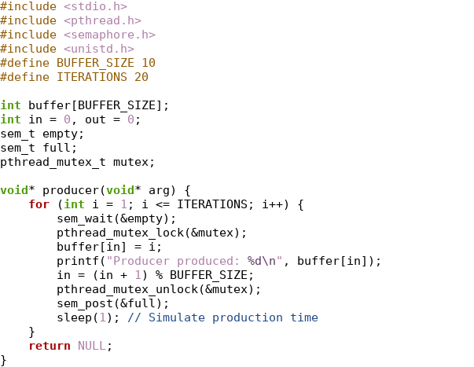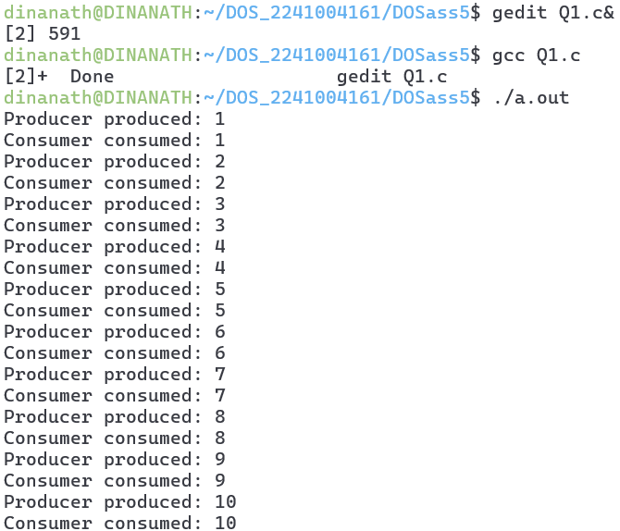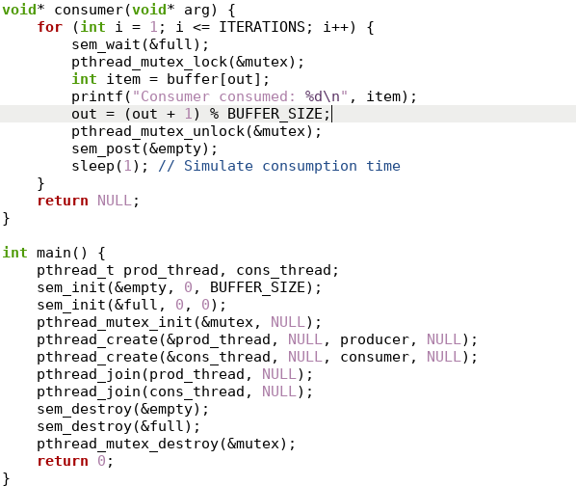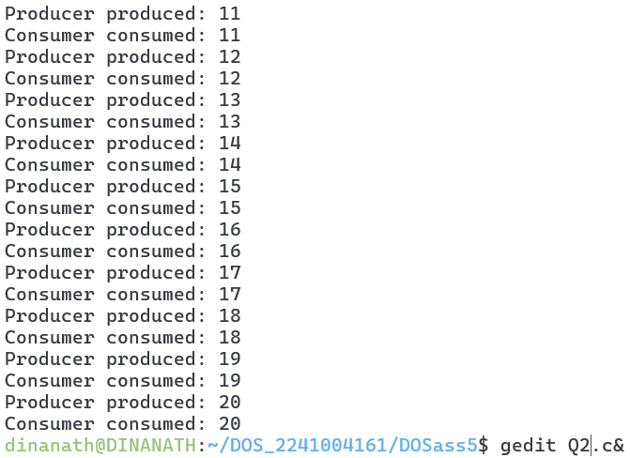

1. Alternating Numbers with Two Threads Problem:

Write a program to print 1, 2, 3 … upto 20. Create threads where two threads print numbers alternately.

* Thread A prints odd numbers: 1, 3, 5 ...
* Thread B prints even numbers: 2, 4, 6 ...

Requirements:

* Use semaphores to control the order of execution of the threads.
* Ensure no race conditions occur.

Output-

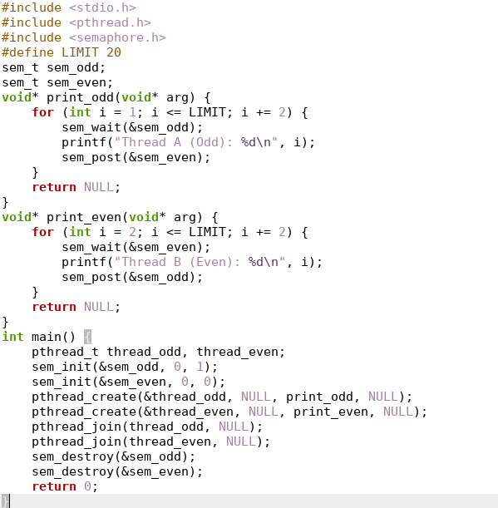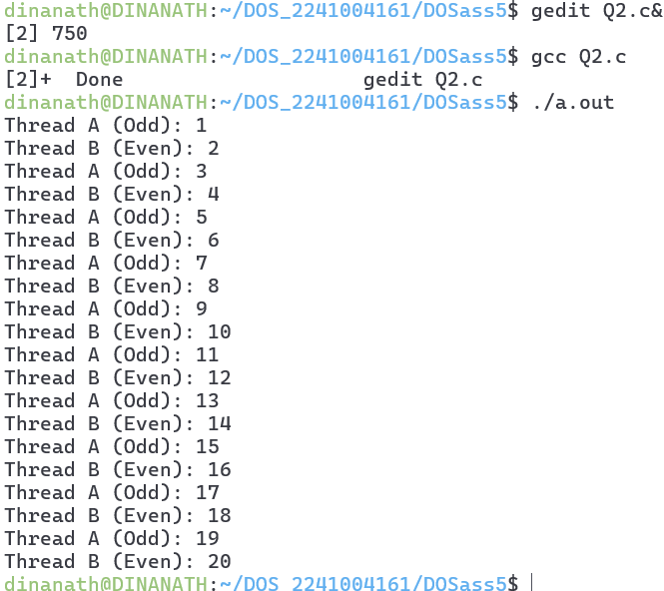

1. Alternating Characters

Problem: Write a program to create two threads that print characters (A and B) alternately such as ABABABABA…. up to 20. Use semaphores to synchronize the threads.

* Thread A prints A.
* Thread B prints B.

Requirements:

* Use semaphores to control the order of execution of the threads.
* Ensure no race conditions occur.

Output-

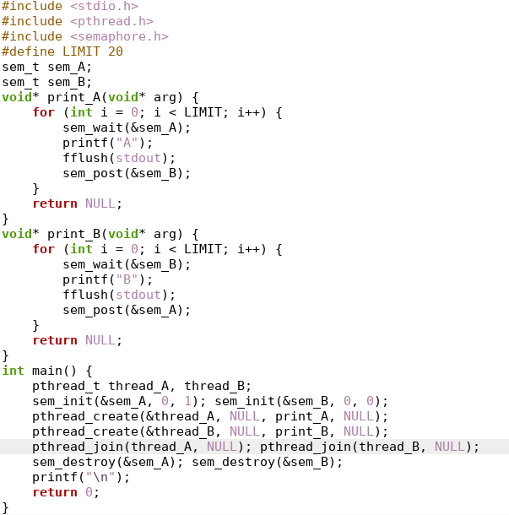

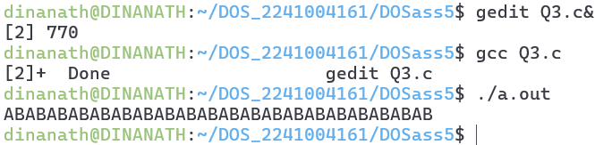

1. Countdown and Countup

Problem: Write a program create two threads where:

* Thread A counts down from 10 to 1.
* Thread B counts up from 1 to 10.

Both threads should alternate execution. Requirements:

* Use semaphores to control the order of execution of the threads.
* Ensure no race conditions occur.

Output-

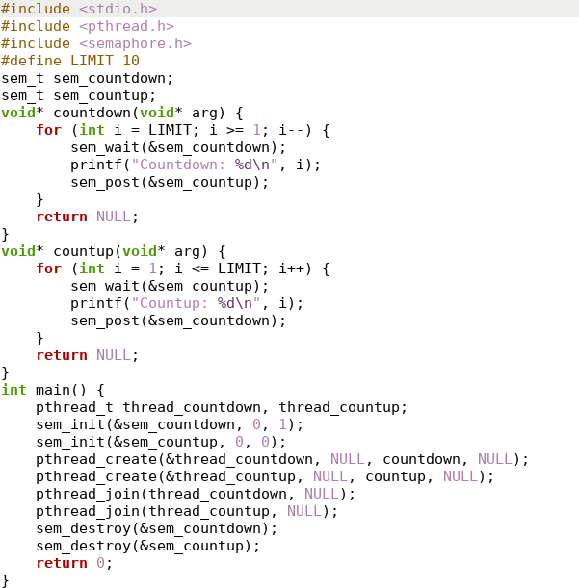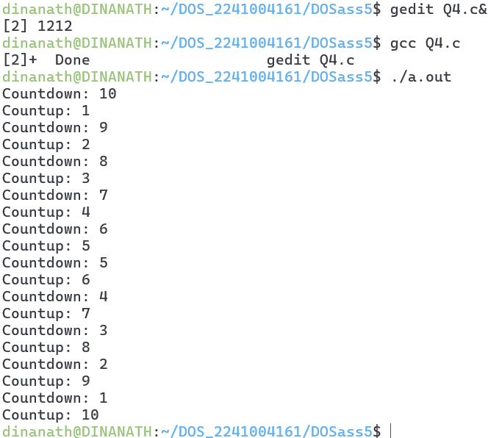

1. Sequence Printing using Threads

Problem: Write a program that creates three threads: Thread A, Thread B, and Thread C. The threads must print numbers in the following sequence: A1, B2, C3, A4, B5, C6 … upto 20 numbers.

* Thread A prints A1, A4, A7, …
* Thread B prints B2, B5, B8, …
* Thread C prints C3, C6, C9, ...

Requirements:

* Use semaphores to control the order of execution of the threads.
* Ensure no race conditions occur.

Output-

